**Identifying Key Predictors of High-risk Drug-Overdose Mortality: A Machine Learning Analysis of U.S. Counties**

Nandita Vaidyanathan

**Abstract**

This study employs machine learning methods to identify county-level predictors of drug overdose mortality risk in the United States. Using probit regression, LASSO, random forest, and XGBoost models, we analyze the relationship between county characteristics and overdose mortality, focusing on health-related and healthcare access, community safety, and sociodemographic factors in the years 2016- 2019. Random Forest and XGBoost models outperformed traditional approaches in prediction accuracy. Our findings highlight frequent mental distress percentage as a critical factor, while healthcare provider metrics showed mixed effects. Demographic analysis identifies non-Hispanic white percentage as the strongest predictor, with rural areas showing increased risk. Economic indicators, including unemployment and income inequality, consistently correlate with higher risk. Notably, violent crime shows minimal association.These insights inform targeted public health interventions at the county level.

**Introduction**

Drug overdose mortality continues to escalate in the United States, remaining to be one of the leading causes of injury mortality (Cerdá et al., 2023). The epidemic has evolved through waves of different substances, with synthetic opioids now driving an unprecedented surge in mortality rates. This crisis stems from multiple factors: the historical over-prescription of opioids for pain management, the proliferation of low-cost high-potency synthetic drugs, and the increasing accessibility of illicit substances through online markets (WHO, 2023b). Monitoring drug-overdose mortality becomes more challenging with the rapidly changing nature of the illicit drug supply environment. Collecting drug overdose data has always been in “hindsight”, using traditional surveillance systems that rely on data from hospital discharge and emergency medical services data (Schell et al., 2021). Being able to forecast drug overdose rates, even if it is for the short term future, and being able to identify key predictors that could point to a high-risk of overdose mortality, can be crucial in directing limited public health resources to vulnerable communities. This is particularly important given the heterogeneous nature of the United States, where demographic, socioeconomic, and healthcare access patterns vary substantially across regions. County-level analysis provides a lens for understanding these patterns, offering granular insights that can inform targeted interventions while capturing the broader community characteristics that influence substance use risks.

Machine learning approaches, while still nascent in drug overdose research, offer powerful tools for detecting complex patterns and interactions among risk factors. Recent studies, particularly those using individual-level data, have demonstrated the power of integrating socioeconomic and behavioral factors into predictive models. However, the application of these techniques to understand county-level patterns of drug overdose risk remains largely unexplored. This study employs four supervised machine learning approaches to identify key county characteristics associated with elevated drug overdose mortality risk across US counties, aiming to provide actionable insights for public health planning and intervention.

**Literature review**

There are many studies that looked at individual-level risk factors of high risk of drug overdose, abuse and disorders. Lowder et al. (2020) used emergency department records to identify individual-level variability in risk factors, and found non-hispanic white males in older ages (65-84 years) had a higher risk of overdose mortality. Other studies find factors associated with social support including family history, lack of family involvement, peer pressure, and loneliness as risk factors of drug addiction (Frankenfeld & Leslie, 2019). Regular smokers, not graduated high school, and unmarried individuals are found to be at an increased risk of prescription opioid-overdose (Lanier et al., 2012). Saloner et al.’s (2020) study included behavioural health and criminal justice variables to their model and found it only marginally improved their predictive model performance for fatal and non-fatal overdose.

Many of these studies use traditional statistical methods to determine causality. For instance, Pike et al. (2020) used a multivariate logistic regression model to study the relationship between drug-use and subsequent nonprescription opioid use among high-school students. Similarly, Saloner et al. (2020) used separate logistic models to predict risk of fatal and nonfatal opioid overdose using clinical and criminal justice data. Geissert et al. (2017) also used logistic models and found model performance of the simpler model, based on receiver operating characteristics, had better predictive power.

Most of these studies have been conducted in unique individual-level populations, making it difficult to generalize to the US population. Frankenfeld & Leslie (2019) argue that county-level analysis is important to study drug-overdose risks as it captures how economic conditions, and social structure influence health outcomes. Studies examining county-level relationships use spatial and non-spatial approaches. Acharya et al. (2022) studied spatio-temporal patterns in opioid overdose rates and used dynamic time warping to identify temporal patterns between counties and multilevel modelling incorporating socio-economic factors. Other spatial studies used censored Poisson regression and negative binomial regression to account for spatial autocorrelation by modelling spatial coordinates of the counties (Haffajee et al. ,2019; Marks et al., 2021; Bozorgi et al.,2021; Frankenfeld and Leslie 2019; Fink et al. 2023). Haffajee et al. (2019) used a spatial logistic model to identify high-risk opioid-overdose counties with low opioid use disorder treatment, and found low primary care provider density, and high rates of unemployment to be top predictors of high-risk.

Use of machine-learning techniques in identifying high-risk drug-overdose has been mostly used in individual-level risk stratification studies. For instance, Lo-Ciganic et al. (2022) used multivariate logistic regression, penalized regression, random forest and gradient-boost techniques to predict opioid overdose in Medicare beneficiaries. They identified gradient-boost to be the best predictor, based on C-statistic and precision-recall curves, similar to other studies (Lo-Ciganic et al. 2019; Lo-Ciganic et al. 2021). One of very few studies that used machine learning techniques using more generalizable data, Bozorgi et al.,(2021) used linear regression, sequential minimal optimization, random forest and extra gradient boosting to identify neighborhood-level predictors of drug-overdose and found that the XGBoost ensembled model of socio-demographic, drug-related and protective resources outperformed all other models, explaining 73% of variation.

While these studies have advanced our understanding of drug overdose risk factors and prediction, several gaps remain. First, most machine learning applications have focused on individual-level risk prediction, with limited exploration of county-level patterns. Second, studies examining county-level relationships have primarily employed spatial statistical approaches, potentially missing complex non-linear relationships between county characteristics and overdose risk. Third, existing research has often focused on specific geographical regions or populations, limiting generalizability. Our study addresses these gaps by employing multiple machine learning approaches to identify county-level characteristics associated with drug overdose mortality risk across the United States. We combine traditional statistical methods probit and LASSO with ensemble learning techniques Random Forest and XGBoost to analyze a comprehensive set of county characteristics from 2016-2019.

**Methodology**

*Data Sources and Variables*

Three main categories of data were considered for this analysis: health-related and healthcare accessibility, community safety, and socio-economic vulnerability. These categories were selected based on established literature examining predictors of drug overdose mortality in the United States. County-level data was obtained from the County Health Rankings & Roadmaps program (Robert Wood Johnson Foundation) for years 2016-2019. This dataset consolidates information from multiple authoritative sources including the Behavioral Risk Factor Surveillance System, American Community Survey, Small Area Health Insurance Survey, CMS National Provider Identification File, FBI Uniform Crime Reporting, and CDC Wonder Mortality Data.

The health-related and healthcare accessibility variables capture both population health status and healthcare system capacity. These include the percentage of frequent mental distress (adults reporting 14+ days of poor mental health per month), percentage of uninsured population, and provider density measures (Primary Care Physicians, other Primary Care Physicians, Mental Health Providers, and Dentists per 100,000 population). Behavioral health factors include the percentage of smokers and excessive drinking. Community safety is measured through violent crime rates per 100,000 population. The socio-economic dimension encompasses demographic factors which include percentage female, percentage non-Hispanic white, rural population percentage, and economic indicators, which include household income, income ratio, unemployment rate, graduation rate, severe housing problems. The final dataset comprises 12,563 observations across 1,856 counties and 23 variables over the four-year period.

The dependent variable is derived from CDC Wonder mortality data on drug overdose deaths. Drug overdose deaths are identified by the underlying cause of death codes from the tenth division of ICD, which include unintentional death, suicide, homicide and undetermined, and involve drug categories that include all drug categories from (T40.1)-(T40.4), which include heroin, natural, semi-synthetic opioids, synthetic opioids, cocaine and psychostimulants. For this analysis, counties with drug-overdose mortality rates in the 75th percentile are considered as high-risk. This threshold helps identify counties experiencing substantially elevated drug overdose mortality rates relative to national patterns.

*Handling Missing Values*

A challenge of dealing with county-level data was handling drug overdose death rate suppression by CDC. We identified 5983 missing values for the drug overdose mortality rate variable. In order to choose the appropriate method for imputing the missing values, we tested for Missing Completely At Random (MCAR) using Little’s MCAR test. The test result rejects the null hypothesis of MCAR (p<0.05), suggesting that the missigness was either missing at random (MAR) or not at random (MNAR).

In the absence of a definitive test to distinguish between Missing At Random (MAR) and Missing Not At Random (MNAR), we employed a reasoned approach based on the nature of drug mortality reporting and county-level data collection. A key feature of our dependent variable, drug overdose mortality rate, is that it follows CDC's data suppression policy: counts fewer than 10 are suppressed for confidentiality reasons, this creates a Missing Not at Random (MNAR) pattern, as the systematic suppression particularly affects smaller counties and those with lower death counts. Standard multiple imputation techniques typically assume Missing at Random (MAR), which is violated in our case. To address this an initial data screening was conducted, removing observations with more than three missing values. Then, we employed a two-step imputation approach to handle missing data in both independent variables and the dependent variable. First, the independent variables were imputed using a multiple imputation method with predictive mean matching (PMM). PMM was chosen because it maintains the original distribution of the variables and preserves the existing variable relationships. M was chosen to be 5 because the number of missing values in the independent variables are moderate, and it provides sufficient accuracy for this analysis, while being computationally efficient. After imputing the independent variables, k-Nearest Neighbor method (kNN), a non-parametric approach, was used to impute the dependent variable, Drug Overdose Mortality Rate. kNN method leverages information from similar counties and accounts for local and regional patterns in mortality rate, with the choice of k=5 balancing local precision and stability (EXPAND). While the imputation approach does not fully account for the MNAR mechanism in the dependent variable, the analysis’s focus on identifying high-risk counties helps mitigate this limitation as these counties are less likely to be affected by the suppression of low counts.

All numeric variables were standardized using the z-score transformation to help comparability between coefficients. Variables with high-skew (population, other primary care provider rate, dentist rate, mental health provider rate, and violent crime rate) were log(x +1) transformed to reduce right skew and handle near-zero values.

*Model Building*

The main goal of the analysis is to identify characteristics associated with counties that experience high-risk drug overdose rates. We will use 4 well-established supervised machine learning methods to identify key predictors of high-risk counties and compare how different models characterize these risks. We use probit regression, least absolute shrinkage and selection operator (LASSO), random forest, and Extreme Gradient Boosting (XGBoost) .

*Probit model*

We use the probit regression model to predict the probability of a binary outcome (drug overdose risk) as a linear combination of its predictors, controlling for the influence of other factors. The dependent variable estimates the probability of a county being a high risk for drug overdose with the given characteristics, where the predicted conditional probabilities lie between 0 and 1, 0 being low-risk and 1 being high-risk. The probit model was chosen as our baseline model due to its ability to estimate binary outcomes while providing interpretable coefficients. The probit model is given as:

P(Y=1∣X)= Φ(β0​+β1​(Socio-economic Vulnerability Variables)+β2​(Health-related and Health Access Variables)+β3​(Community Safety Variables)+ϵ)

Where, P(Y=1∣X) represents the probability of a county being high-risk for drug overdose given the predictors, and Φ represents the cumulative distribution function (CDF) of the standard normal distribution, ensuring predicted probabilities are between 0 and 1, with the coefficients for the predictors. We interpret the model coefficients by converting them to marginal effects.

To assess the probit model's appropriateness and performance, we conducted several diagnostic tests. We examined residual plots to verify model specification and conducted VIF analysis to check for multicollinearity among predictors (See Appendix).The residual plots show the expected pattern for binary response models, with two distinct bands reflecting the binary nature of our outcome. While perfect normality and homoscedasticity aren't expected for binary outcomes, our diagnostic plots indicate appropriate model specification. The Variance Inflation Factor (VIF) analysis shows all values below 5, except frequent mental distress percentage (VIF = 6.41). Given that frequent mental distress is crucial for understanding drug overdose risk, we retain it for our analysis.

*Least Absolute Shrinkage and Selection Operator (LASSO)*

We employed LASSO (Least Absolute Shrinkage and Selection Operator) regularization to address potential overfitting in the probit model and perform variable selection. The choice of LASSO over Ridge regression was motivated by the probit model's coefficient distribution, which showed several strong predictors with large effects while others had coefficients closer to zero. This pattern aligns with LASSO's ability to perform feature selection by shrinking less important coefficients exactly to zero, whereas Ridge regression only reduces coefficient magnitudes.

Using k-fold cross-validation (k=10), we identified the optimal regularization parameter lambda. The consistently low cross-validated lambda values, even when increasing folds to k=10, suggested that the predictors were highly informative with minimal need for regularization. We evaluated both the lambda that minimized cross-validation error (lambda.min) and the more conservative lambda within one standard error of the minimum (lambda.1se). The lambda.1se model produced a more parsimonious solution, eliminating Household Income, Dentist Rate, and Violent Crime Rate variables while maintaining similar predictive performance (AUC = 0.6557) to the more complex model using lambda.min. Given our objectives of model interpretability and parsimony, and comparable test set performance, we selected the more conservative lambda.1se for our final LASSO model.

*Random Forest*

Random Forest is a classification method that uses a series of binary recursive partitioning that involve stratifying the predictor space into mutually exclusive subgroups that share important predictors of the dependent variable. It consists of several classification trees, where each split in the tree considers a random subset of predictors, and averages the resulting predictions. The fact that it considers only a subset of the predictors, decorrelates the trees, reducing overfitting and variance by considering interaction patterns between other variables. The results from our residuals vs fitted plot tells us that there is a non-random pattern in the residuals indicating presence of non-linear relationships that cannot be explained well by generalized linear models.

We employed a Random Forest model with 200 trees, maximum leaf nodes set to 20, and minimum node size of 10 observations. These parameters were selected to balance model complexity with interpretability, focusing on identifying broad patterns in county characteristics while preventing overfitting. The importance parameter was enabled to assess the relative influence of different county characteristics. The chosen parameters demonstrated robust performance without requiring extensive optimization.

*XGBoost*

Building upon our previous models, we implemented XGBoost (eXtreme Gradient Boosting), an advanced machine learning technique that progressively improves predictions by learning from previous errors. Unlike Random Forest, which builds independent trees, XGBoost constructs trees sequentially, with each new tree focusing on correcting the mistakes of the combined previous trees.

Similar to the goals of the other models, we configured the XGBoost model with parameters designed to balance model complexity with generalization. The learning rate (eta) was set to 0.1, deliberately lower than the default to prevent overfitting. Tree complexity was controlled through a maximum depth of 5 and minimum child weight of 2 (minimum weight to create a new node) to avoid excessive complexity. The optimal number of trees was determined through 5-fold cross-validation with early stopping after 20 rounds without improvement.

*Model Evaluation*

For each model, we will split the data set into a training, and testing set, where we fit the algorithm on the training set and test the performance on the testing set. We employ a 70:30 split, where the training data set has 8,794 training samples, which is sufficient to learn county characteristics and relationships, and the testing set has 3,769 samples to reliably evaluate model performance. The partitioning was performed using random sampling with stratification by the binary risk outcome to maintain consistent class distributions across both sets. Given the imbalanced nature of our data (3:1 ratio of low-risk to high-risk counties), we tested two balancing techniques: upsampling and SMOTE. Our primary approach used the upSample function from the caret package, which replicates minority class observations (high-risk counties) to match the number of majority class observations. We also tested SMOTE (Synthetic Minority Over-sampling Technique), which creates synthetic observations of the minority class. Comparing the two approaches, upsampling showed better generalization on the test set for all models. Given this, we proceeded with upsampling as our primary balancing technique, applying it only to the training set to prevent data leakage.

We evaluate the models using various measures. We prioritize metrics that align with the main goal of identifying county characteristics associated with high drug overdose mortality risk. We focus primarily on sensitivity, which measures our models' ability to correctly identify high-risk counties. High sensitivity indicates that the characteristics we identify are genuinely associated with elevated risk status. Precision serves as a complementary metric, indicating the reliability of our identified characteristics in their association with high-risk status. While overall accuracy provides general model performance information, we consider it secondary due to our imbalanced dataset and specific focus on identifying high-risk characteristics. Receiver operating characteristic is also performed, visualizing the tradeoff between sensitivity and specificity. The Area Under the ROC Curve (AUC) quantifies the model's discriminative ability on a scale from 0.5 (random chance) to 1.0 (perfect discrimination). Lastly, we also examine the F1-score, which provides a balanced measure of model performance by sensitivity. For cross-model comparison, we evaluate these metrics on both training and test sets to assess generalization and potential overfitting.

**Results**

*Descriptive statistics*

**Table 1**. Descriptive Statistics

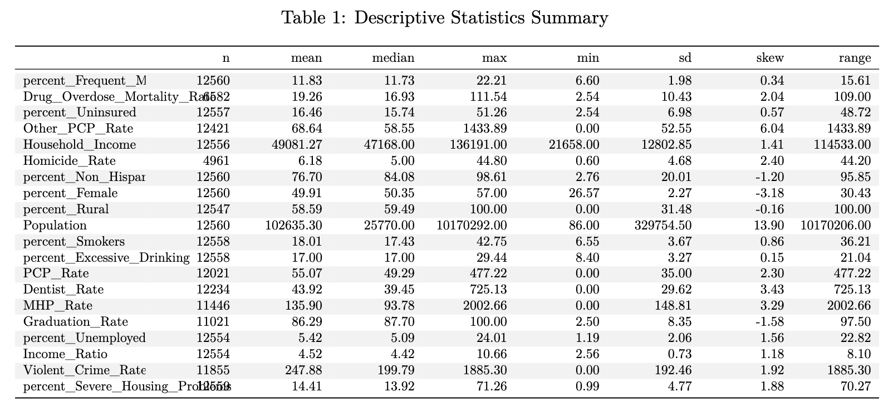

Summary statistics before imputation and standardization from Table 1 tells us a story of the county-level data. The central focus of our study, drug overdose mortality rates, shows considerable variation, with a mean of 19.3 deaths per 100,000 population but reaching as high as 111.5 in severely affected counties. Percentage of frequent mental distress emerges as a significant variable, with counties reporting an average of 11.8% of adults experiencing frequent mental distress, ranging from 6.6% to 22.2%. Mental Health Provider rates vary dramatically, from complete absence in some counties to over 2,000 providers per 100,000 population in others, with a mean of 136 providers. Similar patterns emerge for Primary Care Physicians and dentists, with an average 550 PCPs and 439 dentists per 100,000 population. In terms of health insurance coverage, while the average uninsured rate is 16.5%, some counties face rates as high as 51.3%.

The average county is 76.7% Non-Hispanic White, though this ranges from 2.8% to 98.6%. Rural population percentages span the entire possible range from 0% to 100%, with a mean of 58.6% rural. Population, naturally varies enormously ranging, from 86 to 10 million residents. Household incomes range from $21,658 to $136,191, with a mean of $49,081. The income ratio, measuring economic inequality, averages 4.5, indicating substantial income disparities within counties. Unemployment rates average 5.4% but reach as high as 24% in some areas.

Initial correlation heat map (see Appendix) reveals important relationships between county-level characteristics. We see that the strongest correlation appears among the healthcare provider metrics, PCP rate, MHP rate, other PCP rate and dentist rate, suggesting these resources tend to cluster together in certain counties. We also see that household income is correlated with the healthcare provider rates, suggesting that counties with higher income levels tend to have better access to healthcare resources across all provider types. In terms of socioeconomic interconnections, we see that household income has a strong positive correlation with excessive drinking (r = 0.48). Interestingly, we find that drug overdose mortality rates show positive correlations with smoking rates (r = 0.33) and frequent mental distress (r = 0.37), while having a negative correlation with excessive drinking (r = -0.28).

Analysis of drug overdose mortality rates reveals consistent geographic patterns and concerning trends from 2016 to 2019. West Virginia consistently reported the highest state-level mortality rates, increasing from 34.4 deaths per 100,000 population in 2016 to 42.1 in 2019. Kentucky and New Mexico also consistently ranked among the states with highest mortality rates during the early years of the study period, while Maryland and Ohio emerged among the highest-risk states by 2019.

At the county level, the data shows extreme concentrations of mortality in specific regions. Rio Arriba County, New Mexico, reported 84.9 deaths per 100,000 in 2016, while several West Virginia counties experienced particularly severe rates throughout the study period. McDowell County, West Virginia, recorded 93.2 deaths per 100,000 in 2017, and by 2019, Cabell County, West Virginia, reached the study period's highest rate of 112.0 deaths per 100,000. These county-level rates substantially exceeded their respective state averages, highlighting significant within-state variations in drug overdose mortality risk.

*Prediction Performance*

Table 2. Model Comparison using Performance Metrics

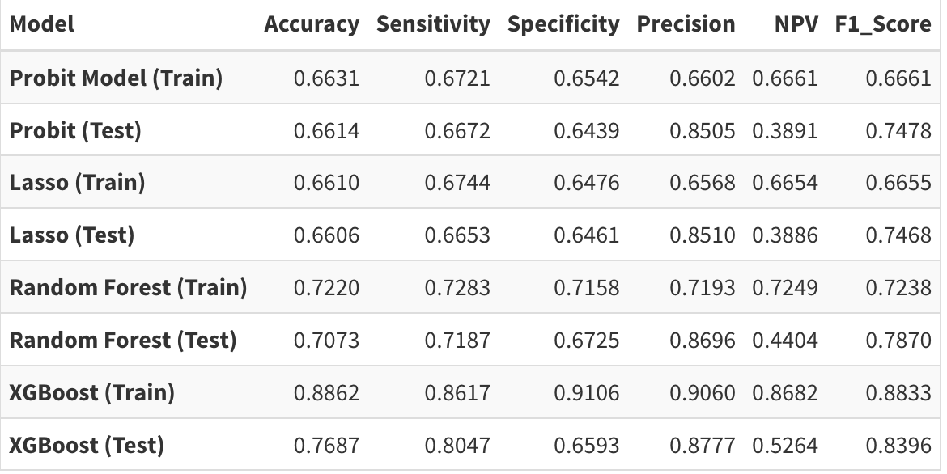

Our analysis employed four different models to identify county characteristics associated with high drug overdose mortality risk. The probit and LASSO models demonstrate notably consistent performance between training and testing sets, with accuracy hovering around 0.66 for both. The Random Forest model shows stronger base performance while maintaining reasonable consistency between training and testing. Its training accuracy of 0.722 decreases modestly to 0.707 on the test set, indicating good generalization. The model's sensitivity of 0.719 on training data carries over well to the test set at 0.719, suggesting reliable identification of high-risk counties. XGBoost demonstrates the highest training performance with 0.886 accuracy and particularly strong specificity (0.911). However, it shows the largest gap between training and testing performance, with test accuracy dropping to 0.769. Despite this decrease, it maintains strong sensitivity (0.805) and precision (0.878) on the test set, suggesting robust predictive power for identifying high-risk counties.

Notably, all models show relatively strong precision on the test set (ranging from 0.851 to 0.878), indicating reliable positive predictions when counties are classified as high-risk. The ensemble methods (Random Forest and XGBoost) achieve higher F1-scores on the test set compared to the linear models, suggesting better overall balance between precision and sensitivity in their predictions.The ROC curves (see Figure 1) illustrate the superior discriminative ability of the ensemble methods compared to the linear models. We can see that the ROC curves of the linear models are overlapping, while we see a clear dominance of the XGBoost model.

**Figure 1.** Comparison of Receiving Operating Characteristic Curves (Testing)

. 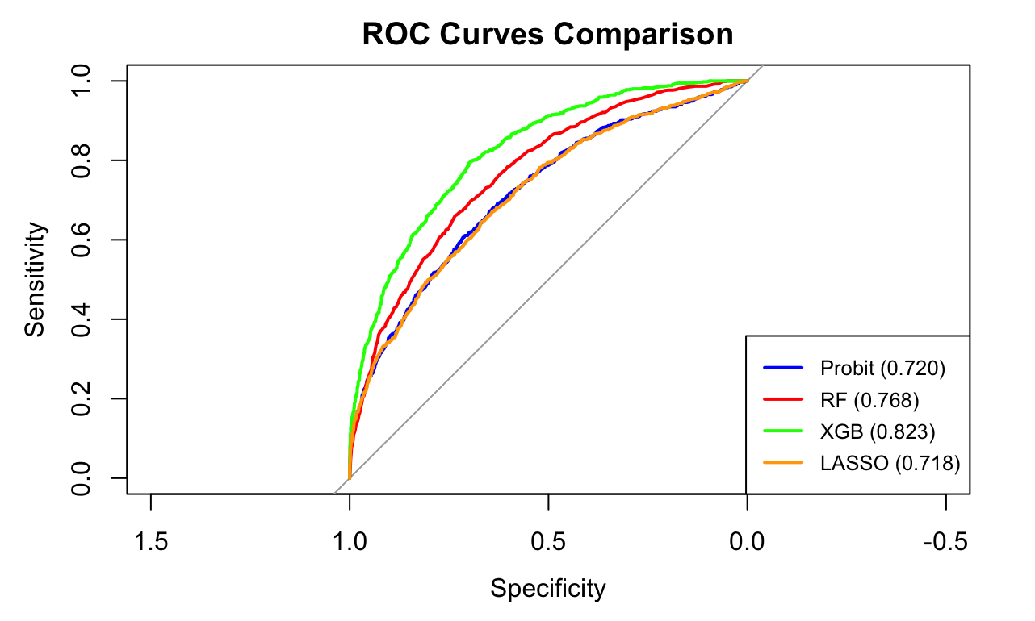

All models demonstrated consistent performance in identifying key county characteristics associated with high drug overdose mortality risk. Examining results (See Appendix for model results) across all models reveals consistent patterns of important predictors within each category. In the health-related and healthcare access domain, frequent mental distress emerges as a strong predictor, ranking among the top three important variables in all models and showing a significant positive association in the probit model (AME = 0.063, p < 0.001). Healthcare provider accessibility demonstrated mixed effects across all models: mental health provider rates consistently showed positive associations with risk (featured prominently in RF and XGBoost importance rankings), while primary care physician rates showed inverse relationships. Both LASSO and RF identified dentist rates as having minimal importance, statistical insignificance in the probit model, and dropped by the LASSO model. Interestingly, excessive drinking demonstrates a consistent negative association. Uninsured population percentage is positively associated with risk.

In the socio-demographic domain, non-Hispanic white population percentage shows the strongest association across all models for high-risk of drug overdose, ranking first in importance for RF and XGBoost and showing the largest marginal effect in the probit model (AME = 0.104, p < 0.001). Rural population percentage is also associated positively with risk, while female population percentage shows a protective negative effect. In terms of economic factors, unemployment rate appeared among the top predictors in all models' importance rankings and showed significant positive association in the probit model (AME = 0.038, p < 0.001) , and income ratio similarly demonstrated consistent positive relationships across all models. Population was also among the top predictors in all models, showing a positive relationship with high-risk (AME= 0.053, p< 0.001).

In the community safety domain, violent crime rate showed a consistently low and insignificant association with high-risk drug overdose. Notably, all models indicated a significant temporal trend, with risk of drug overdose mortality increasing over the study period (2016-2019). This temporal effect ranked among the top predictors in importance across models.

**Discussion**

In recent years, the risk of drug-overdose mortality rates in the U.S has been escalating. We see a clear temporal trend– from 2016, the national average of drug overdose mortality increased from 17.4 deaths per 100,000 to 21.0 in 2019. It is evident that the crisis is getting worse with time. This growth is largely driven by synthetic opioids, the latest wave of drug overdose mortality. Although the opioid crisis was officially announced in 2017, the third wave of the opioid crisis started growing in 2013 with the emergence of synthetic opioids (Zhao et al., 2024). Ciccarone (2019) suggests that this growth is an outcome of the combined forces of demand (social, cultural and technological elements) and supply (new illicit sources of drugs).

We identified non-hispanic white population percentage as a top predictor of a high-risk drug-overdose county. This aligns with CDC's 2017 findings that counties with higher non-Hispanic white populations have higher opioid prescription rates. The relationship likely reflects documented disparities in prescribing practices: despite evidence that racial and ethnic minorities experience similar or higher pain levels, non-Hispanic white patients receive more frequent prescriptions, higher doses, and longer duration of opioid medications (Singhal et al., 2016; Alexander et al., 2018). These prescribing patterns may contribute to increased overdose risk in predominantly white communities.

Frequent mental distress percentage being a high predictor of high-risk drug overdose aligns with recent research on poor mental health status being inherently linked to substance abuse disorders (SUD) and drug overdose risk, which is a sequence of SUDs (Kedia et al., 2022). Research by Foley and Schwab-Reese (2018) find a relationship between depression and associated increase in fatal opioid-overdose deaths in the US. Gicquelais et al. (2020) find similar trends finding links between suicidal ideation associated with higher risk of opioid overdose hospitalization. SUDs and drug-overdose rates are inextricably linked with income inequality, and poverty, with lower-income communities being less likely to have access to healthcare resources and access to treatment. We find that counties with higher uninsured populations have associated high-risk for drug-overdose, a finding in line with research (Wu & Ringwalt, 2005).

Our study finds an inverse relationship between PCPs and drug-overdose risk, in line with research by Haffajee et al., (2019) finding that opioid high-risk counties are characterised by lower proportions of PCPs and MHPs . Our finding that the density of MHPs have a positive relationship with drug-overdose warrants careful consideration. We argue that the positive association doesn't imply that mental health providers contribute to drug overdose risk, but rather might reflect complex patterns of healthcare resource allocation and underlying community needs. For instance, increased mental health providers density could be in response to counties having higher drug-overdose cases. Moreover, counties with higher density of MHPs would mean the county has better detection and reporting of drug-overdose cases. Ruhm (2017) finds that one fourth of all drug-overdose death certificates fail to note the specific drug that caused the fatality, and this underreporting is found substantially in counties with poorer medical infrastructure.

There are also clear geographic variations that are evident. West Virginia consistently dominates the list of highest-risk counties, with rural counties like McDowell, Wyoming, and Boone repeatedly appearing among the top rates. By 2019, we also see the emergence of an urban center in the list - Baltimore City, Maryland - suggesting the crisis may be evolving to affect both rural and urban areas more severely. Our analysis finds that countries with that rural percentage is a top predictor of having higher risk of overdose. Studies (King et al., 2014; García et al., 2019) show that rural populations are more likely to have opioid-related mortality and have higher opioid prescription rates. Population, another top predictor of drug-overdose from our analysis, is consistent with other research indicating denser counties having higher drug-overdose rates(Bozorgi et al., 2021).

Despite studies (Cano et al., 2022; Krawczyk et al., 2019) finding smoking and alcohol consumption to be associated with drug-abuse, we find no significance for percentage of smoking, and an inverse relationship with excessive drinking, suggesting a possible substitution effect. To better understand the inverse relationship between excessive drinking and drug-overdose risk, further exploration is warranted.

Methodologically, the Random Forest and XGBoost demonstrated superior overall performance compared to the traditional linear models, Probit and LASSO. While previous studies in drug overdose risk prediction have found gradient boosting methods to be optimal (Lo-Ciganic et al., 2022; Lo-Ciganic et al. 2019; Lo-Ciganic et al. 2021), our Random Forest model showed more balanced and robust performance across metrics. Although XGBoost achieved higher accuracy (0.769) and sensitivity (0.805) on the test set, it showed a notable drop in specificity (0.659), suggesting potential overfitting despite its high training performance (accuracy: 0.886). In contrast, the Random Forest model maintained more consistent performance between training and testing sets (accuracy: 0.722 and 0.708 respectively), with balanced sensitivity (0.720) and the highest test set F1-score (0.788) among all models. Random Forest's more balanced sensitivity suggests more reliable overall predictions, because for our specific goal of identifying county characteristics, model stability is crucial. Both Probit and LASSO models showed comparable but lower performance metrics (test accuracy around 0.66), though they offer advantages in interpretability of coefficient estimates.

**Conclusion**

Our analysis reveals several crucial insights for addressing the drug overdose crisis at the county level. Mental health emerges as a critical factor, with the positive association with mental health provider rates indicating that current mental health resources are being allocated reactively rather than preventively. Public health professionals should place increasing importance to strengthen integration of mental health and substance use treatment services, and develop early intervention programs in counties with high mental distress rates. Given primary care services’ protective effect on drug overdose mortality rate risk, increasing access to substance use treatment through primary care settings, with a focus on creating innovative healthcare delivery models for rural counties seem crucial.

It is important to note that while non-hispanic white population percentage emerges as a key predictor, it reflects historical prescribing patterns, and masks the underlying factors associated with high-risk. Future research should focus on underlying systemic factors rather than racial demographics to better understand and address the root causes of overdose risk. The clear geographic patterns in our findings suggest that incorporating spatial analysis could provide additional insights by examining regional clusters and accounting for spatial autocorrelation.

In terms of machine learning models, random forest emerges as the best model in terms of striking a balance between generalizability, consistency, and interpretability. However, future research could enhance these findings through more extensive hyperparameter optimization and exploration of complex models like Deep Neural Networks.

**Appendix**

Figure A.1 Probit Model Diagnostic Plots

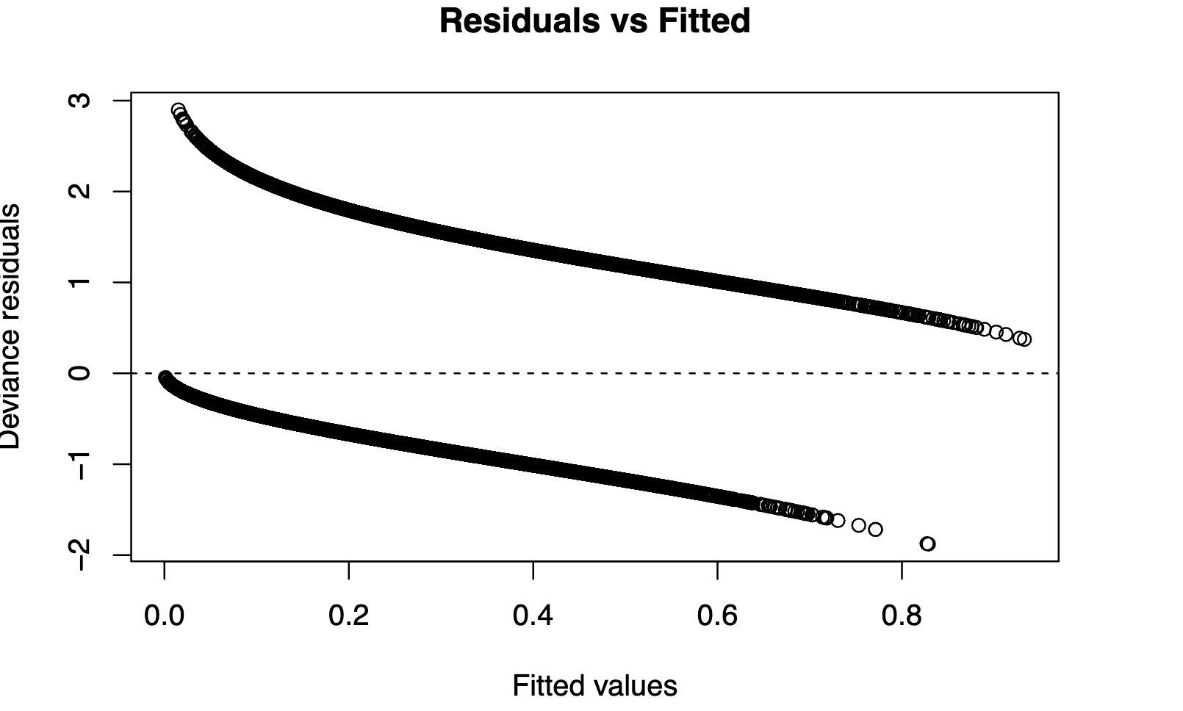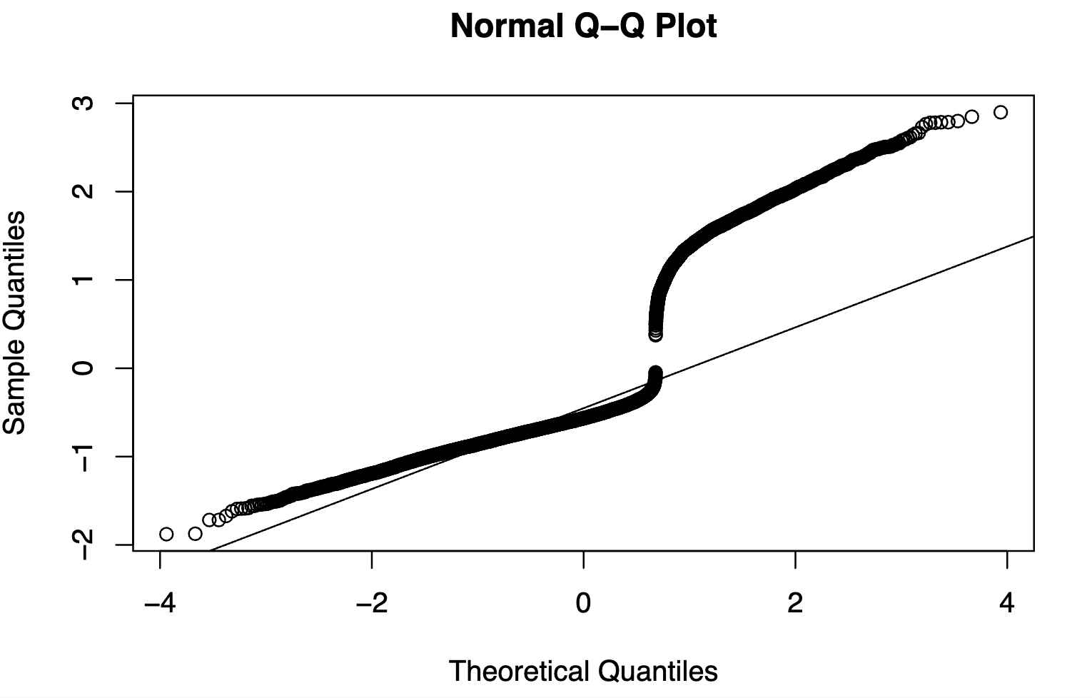

The Probit model's diagnostic plots suggest satisfactory adherence to underlying assumptions. The residuals versus fitted values plot shows no systematic patterns, suggesting the model adequately captures the relationships in the data. These diagnostics support the validity of our probit specification. The Q-Q plot indicates that residuals largely follow the theoretical normal distribution, with some minor deviations in the tails that are typical for binary response models.

Table A.1. Variance Inflation Factor for Probit Model

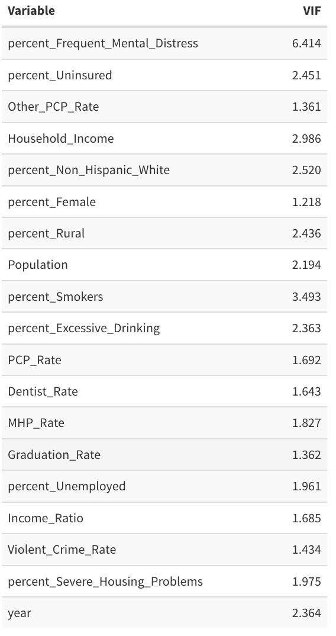

Variance Inflation Factor (VIF) analysis indicates minimal multicollinearity concerns among predictors, with most variables showing VIF values below 5. While the Frequent Mental Distress variable exhibits moderate multicollinearity, its theoretical importance to drug overdose risk and consistent significance across models justifies its retention in our analysis.

Figure A.2 Correlation Heatmap

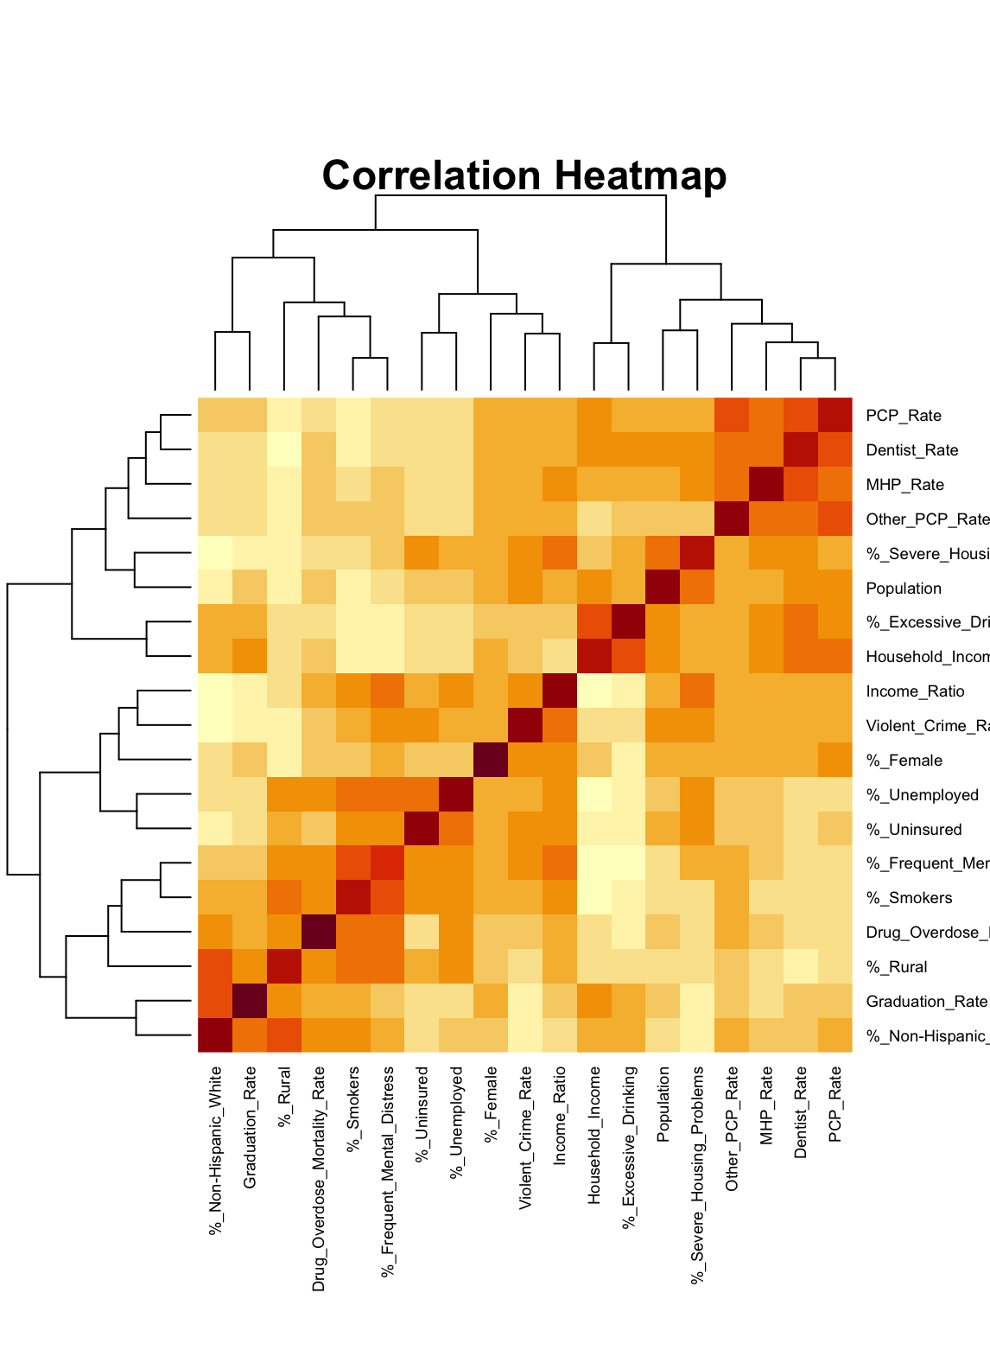

The correlation matrix (Figure A.2) presents the pairwise correlations between key variables in our analysis. Dark cells indicate strong positive correlations, while lighter shades represent weaker associations. The diagonal shows perfect correlation (1.0) as variables correlate perfectly with themselves.

Table A.2. Probit Results with Average Marginal Effects

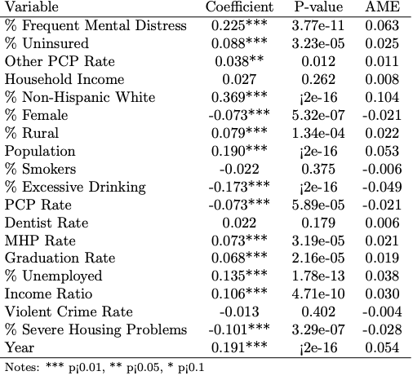

Based on the estimates from the probit model, we find that percentage of Non-Hispanic White has the strongest association with high-risk of drug overdose, with a one percentage point increase in non-Hispanic white population is associated with a 0.104 increase in the probability of a county being classified as high-risk (p < 0.001). The second strongest predictor is percentage of frequent mental distress in a county, indicating that a one percentage point increase in frequent mental distress is associated with a 0.063 increase in probability of high-risk classification (p < 0.001). Size of population and year demonstrate equally significant effects, each associated with a 0.053 increase in high-risk probability (p < 0.001). Rural areas demonstrate a significant positive association, with a one percentage point increase in rural population corresponding to a 0.022 increase in high-risk probability (p < 0.001).

Healthcare access measures reveal mixed effects. Mental health provider rates show a positive association (0.021, p < 0.001), while primary care physician rates demonstrate a negative relationship (-0.021, p < 0.001). Other primary care provider rates show a weaker but still significant positive association (0.011, p < 0.05). However, dentist rates show no significant association with high-risk probability (0.006, p > 0.05). Notably, excessive drinking demonstrates a protective association, with a one percentage point increase corresponding to a 0.049 decrease in high-risk probability (p < 0.001). Smoking rates show no significant association with high-risk classification (-0.006, p > 0.05). The percentage of uninsured population demonstrates a positive association (0.025, p < 0.001).

Socio-economic factors also show notable associations, with unemployment showing a 0.038 increase in high-risk probability (p < 0.001). Higher graduation rates correspond to a 0.019 increase in high-risk probability (p < 0.001), and income inequality shows a 0.030 increase (p < 0.001). In terms of community-safety variables, severe housing problems demonstrate an unexpected negative association (-0.028, p < 0.001), while violent crime rates show no significant relationship with high-risk classification (-0.004, p > 0.05).

Figure A.3 LASSO Coefficients Plot

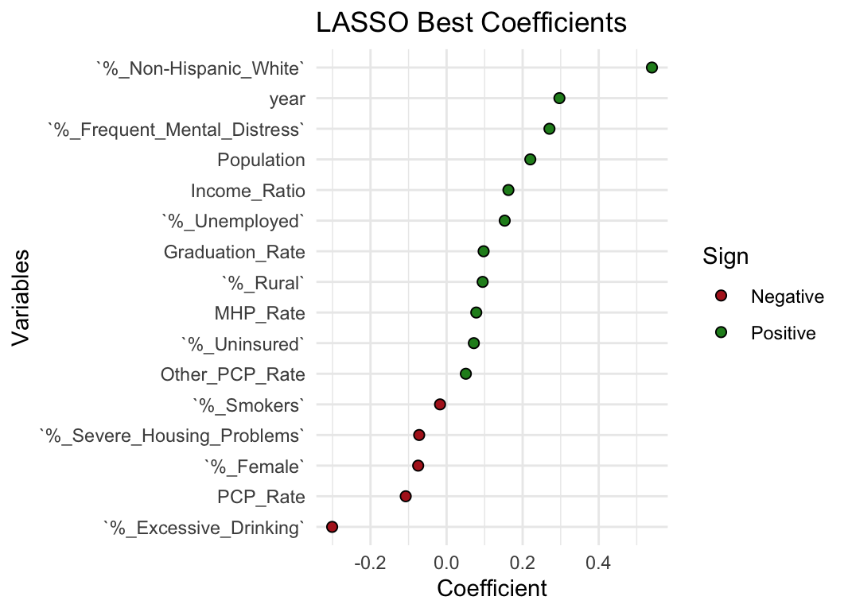

Figure A.3 presents the best coefficients identified through LASSO regularization, displaying the magnitude and direction of relationships between key variables and the outcome measure. The coefficients are standardized for comparative interpretation. Non-Hispanic White population composition shows the strongest positive association (0.4), followed by Frequent Mental Distress (0.3). Among the negative associations, excessive drinking demonstrates the most substantial impact (-0.2).

Figure A.4 Random Forest’s Error Rate

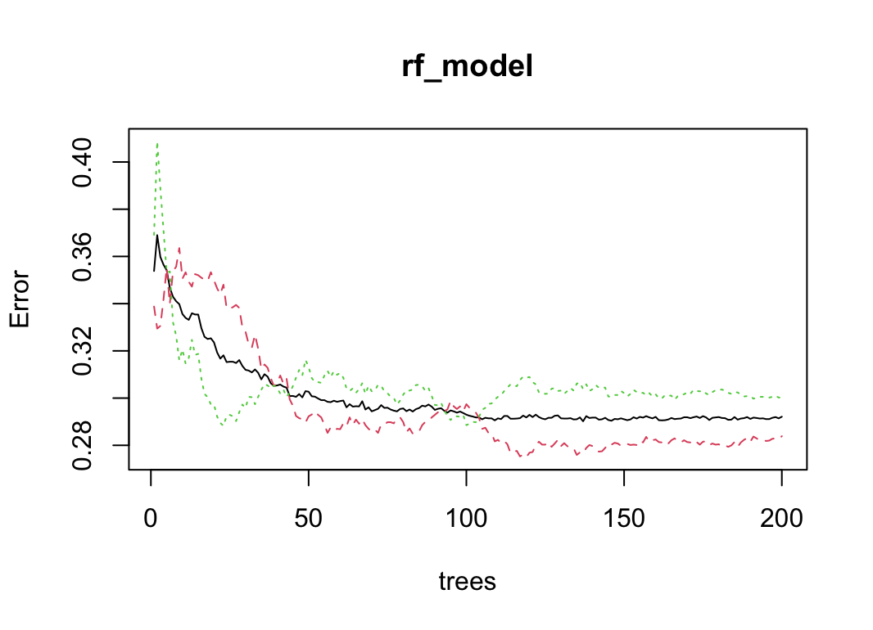

From this figure, we can see that the error rate stabilises after adding about 150 trees to our random forest model. The black line represents the Out-of-Bag (OOB) error, which provides an unbiased estimate of the model's generalization performance. The dotted lines represent error rates for different classes, showing initial volatility before converging alongside the OOB error. This convergence pattern suggests that our chosen number of trees, 200, is sufficient for model stability, as additional trees beyond 100 yield minimal improvement in predictive accuracy.

Figure A.5 Random Forest’s Feature Importance Rankings

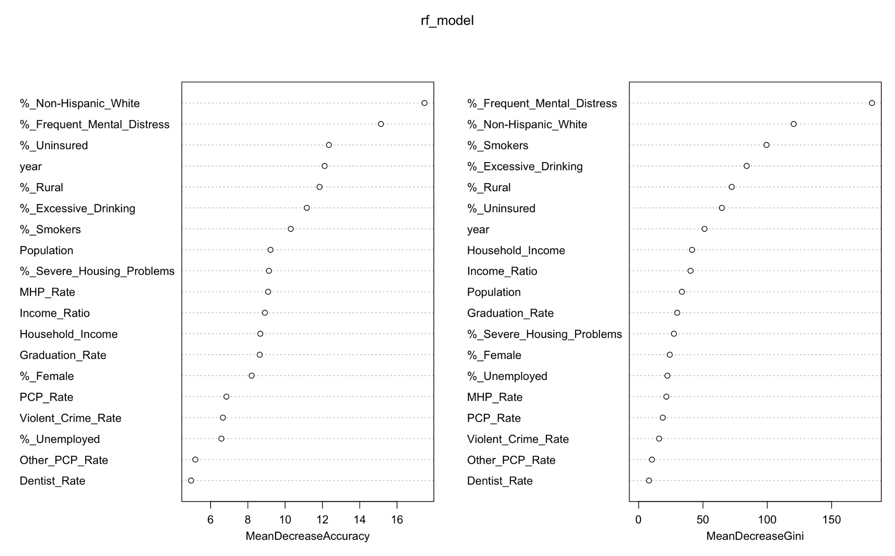

Figure A.4 displays the random forest model's feature importance rankings through two key metrics: Mean Decrease Accuracy and Mean Decrease Gini. The Mean Decrease Accuracy measure, shown in the left panel, indicates how model accuracy declines when each variable is randomly permuted. Higher values suggest greater variable importance, with Non-Hispanic White percentage and Frequent Mental Distress emerging as the most crucial predictors.

The Mean Decrease Gini provides complementary evidence by measuring each variable's ability to create pure splits in the random forest trees. This metric confirms the prominence of our key demographic and mental health variables, while also highlighting the relatively lower importance of healthcare supply measures such as Dentist Rate and Other PCP Rate.

Figure A.5 XGBoost Feature Importance

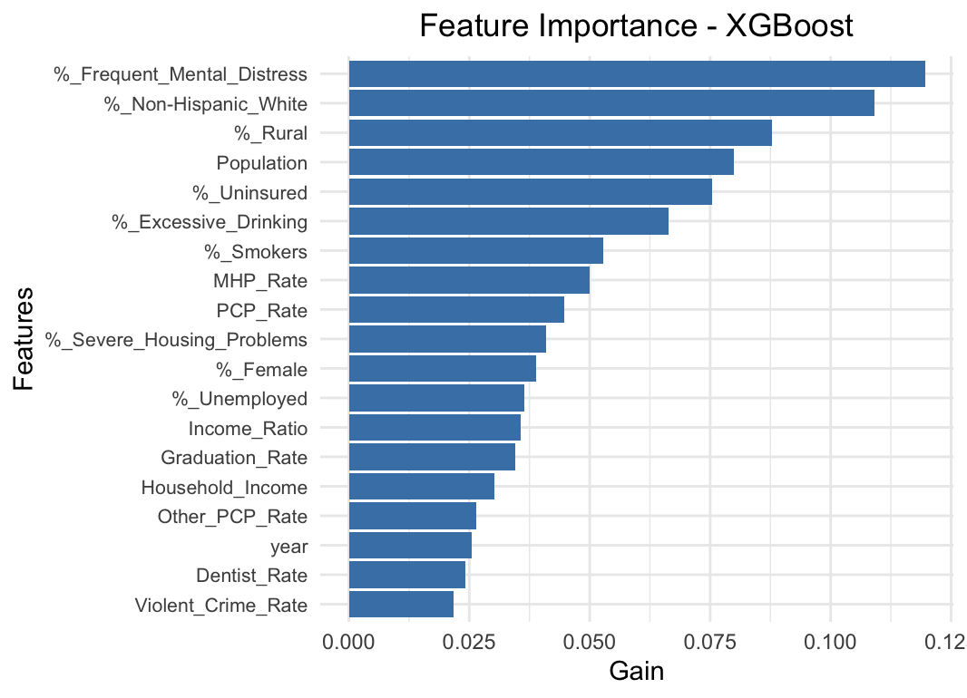

This figure shows the feature importance plot from the XGBoost model showing gain in accuracy of the model brought by the features to the model. Frequent mental distress emerges as the top variable suggesting it is relatively more important for prediction, closely followed by other demographic variables.

**References**

Acharya, A., Izquierdo, A. M., Gonçalves, S. F., Bates, R. A., Taxman, F. S., Slawski, M. P., Rangwala, H. S., & Sikdar, S. (2022). Exploring county-level spatio-temporal patterns in opioid overdose related emergency department visits. *PLoS ONE*, *17*(12), e0269509. https://doi.org/10.1371/journal.pone.0269509

Bozorgi, P., Porter, D. E., Eberth, J. M., Eidson, J. P., & Karami, A. (2021). The leading neighborhood-level predictors of drug overdose: A mixed machine learning and spatial approach. *Drug and Alcohol Dependence*, *229*, 109143. https://doi.org/10.1016/j.drugalcdep.2021.109143

Cano, M., Oh, S., Osborn, P., Olowolaju, S. A., Sanchez, A., Kim, Y., & Moreno, A. C. (2022). County-level predictors of US drug overdose mortality: A systematic review. *Drug and Alcohol Dependence*, *242*, 109714. https://doi.org/10.1016/j.drugalcdep.2022.109714

Cerdá, M., Krawczyk, N., & Keyes, K. (2023). The future of the United States Overdose crisis: challenges and opportunities. *Milbank Quarterly*, *101*(S1), 478–506. https://doi.org/10.1111/1468-0009.12602

Ciccarone, D. (2019). The triple wave epidemic: Supply and demand drivers of the US opioid overdose crisis. *International Journal of Drug Policy*, *71*, 183–188. https://doi.org/10.1016/j.drugpo.2019.01.010

Fink, D. S., Keyes, K. M., Branas, C., Cerdá, M., Gruenwald, P., & Hasin, D. (2023). Understanding the differential effect of local socio‐economic conditions on the relation between prescription opioid supply and drug overdose deaths in US counties. *Addiction*, *118*(6), 1072–1082. https://doi.org/10.1111/add.16123

Foley, M., & Schwab-Reese, L. M. (2018). Associations of state-level rates of depression and fatal opioid overdose in the United States, 2011–2015. *Social Psychiatry and Psychiatric Epidemiology*, *54*(1), 131–134. https://doi.org/10.1007/s00127-018-1594-y

Frankenfeld, C. L., & Leslie, T. F. (2019). County-level socioeconomic factors and residential racial, Hispanic, poverty, and unemployment segregation associated with drug overdose deaths in the United States, 2013–2017. *Annals of Epidemiology*, *35*, 12–19. https://doi.org/10.1016/j.annepidem.2019.04.009

García, M. C., Heilig, C. M., Lee, S. H., Faul, M., Guy, G., Iademarco, M. F., Hempstead, K., Raymond, D., & Gray, J. (2019). Opioid prescribing rates in nonmetropolitan and metropolitan counties among primary care providers using an Electronic Health Record System — United States, 2014–2017. *MMWR Morbidity and Mortality Weekly Report*, *68*(2), 25–30. https://doi.org/10.15585/mmwr.mm6802a1

Geissert, P., Hallvik, S., Van Otterloo, J., O’Kane, N., Alley, L., Carson, J., Leichtling, G., Hildebran, C., Wakeland, W., & Deyo, R. A. (2017). High-risk prescribing and opioid overdose: prospects for prescription drug monitoring program–based proactive alerts. *Pain*, *159*(1), 150–156. https://doi.org/10.1097/j.pain.0000000000001078

Gicquelais, R. E., Jannausch, M., Bohnert, A. S., Thomas, L., Sen, S., & Fernandez, A. C. (2020). Links between suicidal intent, polysubstance use, and medical treatment after non-fatal opioid overdose. *Drug and Alcohol Dependence*, *212*, 108041. https://doi.org/10.1016/j.drugalcdep.2020.108041

Guy, G. P., Zhang, K., Bohm, M. K., Losby, J., Lewis, B., Young, R., Murphy, L. B., & Dowell, D. (2017). Vital signs: Changes in opioid prescribing in the United States, 2006–2015. *MMWR Morbidity and Mortality Weekly Report*, *66*(26), 697–704. https://doi.org/10.15585/mmwr.mm6626a4

Haffajee, R. L., Lin, L. A., Bohnert, A. S. B., & Goldstick, J. E. (2019). Characteristics of US counties with high opioid overdose mortality and low capacity to deliver medications for opioid use disorder. *JAMA Network Open*, *2*(6), e196373. https://doi.org/10.1001/jamanetworkopen.2019.6373

Haq, N., McMahan, V. M., Torres, A., Santos, G., Knight, K., Kushel, M., & Coffin, P. O. (2021). Race, pain, and opioids among patients with chronic pain in a safety-net health system. *Drug and Alcohol Dependence*, *222*, 108671. https://doi.org/10.1016/j.drugalcdep.2021.108671

Kedia, S., Dillon, P. J., Schmidt, M., Entwistle, C., & Arshad, H. (2022). Public health impacts of drug overdose and mental health. In *Springer eBooks* (pp. 1–24). https://doi.org/10.1007/978-3-030-67928-6_14-1

King, N. B., Fraser, V., Boikos, C., Richardson, R., & Harper, S. (2014). Determinants of Increased Opioid-Related Mortality in the United States and Canada, 1990–2013: A Systematic review. *American Journal of Public Health*, *104*(8), e32–e42. https://doi.org/10.2105/ajph.2014.301966

Knowlton, A., Weir, B. W., Hazzard, F., Olsen, Y., McWilliams, J., Fields, J., & Gaasch, W. (2013). EMS runs for suspected opioid overdose: Implications for surveillance and prevention. *Prehospital Emergency Care*, *17*(3), 317–329. https://doi.org/10.3109/10903127.2013.792888

Krawczyk, N., Eisenberg, M., Schneider, K. E., Richards, T. M., Lyons, B. C., Jackson, K., Ferris, L., Weiner, J. P., & Saloner, B. (2019). Predictors of Overdose Death among High-Risk Emergency Department Patients with Substance-Related Encounters: A Data Linkage Cohort study. *Annals of Emergency Medicine*, *75*(1), 1–12. https://doi.org/10.1016/j.annemergmed.2019.07.014

Lanier, W. A., Johnson, E. M., Rolfs, R. T., Friedrichs, M. D., & Grey, T. C. (2012). Risk Factors for Prescription Opioid-Related Death, Utah, 2008–2009. *Pain Medicine*, *13*(12), 1580–1589. https://doi.org/10.1111/j.1526-4637.2012.01518.x

Lo-Ciganic, W., Donohue, J. M., Hulsey, E. G., Barnes, S., Li, Y., Kuza, C. C., Yang, Q., Buchanich, J., Huang, J. L., Mair, C., Wilson, D. L., & Gellad, W. F. (2021). Integrating human services and criminal justice data with claims data to predict risk of opioid overdose among Medicaid beneficiaries: A machine-learning approach. *PLoS ONE*, *16*(3), e0248360. https://doi.org/10.1371/journal.pone.0248360

Lo-Ciganic, W., Donohue, J. M., Yang, Q., Huang, J. L., Chang, C., Weiss, J. C., Guo, J., Zhang, H. H., Cochran, G., Gordon, A. J., Malone, D. C., Kwoh, C. K., Wilson, D. L., Kuza, C. C., & Gellad, W. F. (2022). Developing and validating a machine-learning algorithm to predict opioid overdose in Medicaid beneficiaries in two US states: a prognostic modelling study. *The Lancet Digital Health*, *4*(6), e455–e465. https://doi.org/10.1016/s2589-7500(22)00062-0

Lo-Ciganic, W., Huang, J. L., Zhang, H. H., Weiss, J. C., Wu, Y., Kwoh, C. K., Donohue, J. M., Cochran, G., Gordon, A. J., Malone, D. C., Kuza, C. C., & Gellad, W. F. (2019). Evaluation of Machine-Learning Algorithms for predicting opioid overdose risk among Medicare beneficiaries with opioid prescriptions. *JAMA Network Open*, *2*(3), e190968. https://doi.org/10.1001/jamanetworkopen.2019.0968

Lowder, E. M., Amlung, J., & Ray, B. R. (2020). Individual and county-level variation in outcomes following non-fatal opioid-involved overdose. *Journal of Epidemiology & Community Health*, *74*(4), 369–376. https://doi.org/10.1136/jech-2019-212915

Ly, D. P. (2021). Association of patient race and ethnicity with differences in opioid prescribing by primary care physicians for older adults with new low back pain. *JAMA Health Forum*, *2*(9), e212333. https://doi.org/10.1001/jamahealthforum.2021.2333

Marks, C., Abramovitz, D., Donnelly, C. A., Carrasco-Escobar, G., Carrasco-Hernández, R., Ciccarone, D., González-Izquierdo, A., Martin, N. K., Strathdee, S. A., Smith, D. M., & Bórquez, A. (2021). Identifying counties at risk of high overdose mortality burden during the emerging fentanyl epidemic in the USA: a predictive statistical modelling study. *The Lancet Public Health*, *6*(10), e720–e728. https://doi.org/10.1016/s2468-2667(21)00080-3

Pike, J. R., Fadardi, J. S., Stacy, A. W., & Xie, B. (2020). The prospective association between illicit drug use and nonprescription opioid use among vulnerable adolescents. *Preventive Medicine*, *143*, 106383. https://doi.org/10.1016/j.ypmed.2020.106383

Ruhm, C. J. (2017). Geographic variation in opioid and heroin involved drug poisoning mortality rates. *American Journal of Preventive Medicine*, *53*(6), 745–753. https://doi.org/10.1016/j.amepre.2017.06.009

Saloner, B., Chang, H., Krawczyk, N., Ferris, L., Eisenberg, M., Richards, T., Lemke, K., Schneider, K. E., Baier, M., & Weiner, J. P. (2020). Predictive modeling of opioid overdose using linked statewide medical and criminal justice data. *JAMA Psychiatry*, *77*(11), 1155. https://doi.org/10.1001/jamapsychiatry.2020.1689

Schell, R. C., Allen, B., Goedel, W. C., Hallowell, B. D., Scagos, R., Li, Y., Krieger, M. S., Neill, D. B., Marshall, B. D. L., Cerda, M., & Ahern, J. (2021). Identifying predictors of opioid overdose death at a neighborhood level with machine learning. *American Journal of Epidemiology*, *191*(3), 526–533. https://doi.org/10.1093/aje/kwab279

World Health Organization: WHO. (2023a, August 29). *Opioid overdose*. https://www.who.int/news-room/fact-sheets/detail/opioid-overdose#:~:text=The%20number%20of%20opioid%20overdoses,on%20the%20illicit%20drug%20market.

World Health Organization: WHO. (2023b, August 29). *Opioid overdose*. https://www.who.int/news-room/fact-sheets/detail/opioid-overdose#:~:text=The%20number%20of%20opioid%20overdoses,on%20the%20illicit%20drug%20market.

Wu, L., & Ringwalt, C. (2005). Use of substance abuse services by young uninsured American adults. *Psychiatric Services*, *56*(8), 946–953. https://doi.org/10.1176/appi.ps.56.8.946

Zedler, B., Xie, L., Wang, L., Joyce, A., Vick, C., Kariburyo, F., Rajan, P., Baser, O., & Murrelle, L. (2014). Risk Factors for Serious Prescription Opioid-Related Toxicity or Overdose among Veterans Health Administration Patients. *Pain Medicine*, *15*(11), 1911–1929. https://doi.org/10.1111/pme.12480

Zhao, Y., Liu, Y., Lv, F., He, X., Ng, W. H., Qiu, S., Zhang, L., Xing, Z., Guo, Y., Zu, J., Yeo, Y. H., & Ji, F. (2024). Temporal trend of drug overdose-related deaths and excess deaths during the COVID-19 pandemic: a population-based study in the United States from 2012 to 2022. *EClinicalMedicine*, *74*, 102752. https://doi.org/10.1016/j.eclinm.2024.102752